**Lesson21 Azure File Share**

**Notes:-**

**1-with azure file share > you can create file share and access to it through port 445**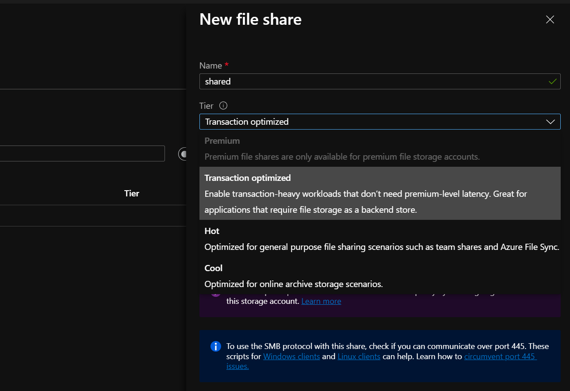

**(You see in order to access to premium option, you have to create storage account of type file share)**

**2-on the Shared Files > create file share > connect > we copy the code and open PowerShell and paste it as below**

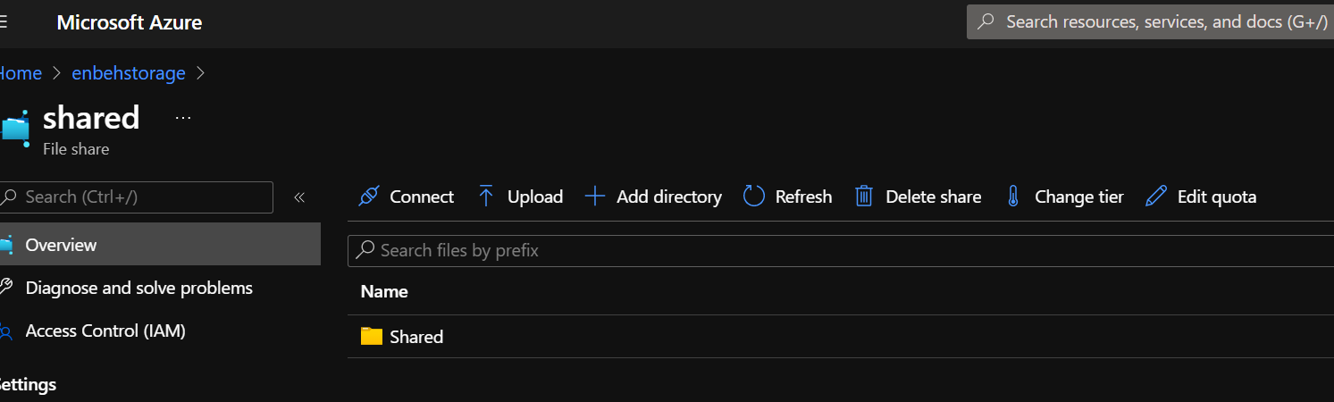

**$connectTestResult = Test-NetConnection -ComputerName enbehstorage.file.core.windows.net -Port 445**

**if ($connectTestResult.TcpTestSucceeded) {**

**# Save the password so the drive will persist on reboot**

**cmd.exe /C "cmdkey /add:`"enbehstorage.file.core.windows.net`" /user:`"localhost\enbehstorage`" /pass:`"X03N0tgJQnvxC6KJPYi8zpaKrtoxabzFKuxalRBsiBXS4M27y/2OGE41sL6or+kPuOShoqc6MHcBA89qlHQO4Q==`""**

**# Mount the drive**

**New-PSDrive -Name Z -PSProvider FileSystem -Root "\\enbehstorage.file.core.windows.net\shared" -Persist**

**} else {**

**Write-Error -Message "Unable to reach the Azure storage account via port 445. Check to make sure your organization or ISP is not blocking port 445, or use Azure P2S VPN, Azure S2S VPN, or Express Route to tunnel SMB traffic over a different port."**

**}**

**Then we apply the following command**

**Z:\ (The directory it declared on previous step)**

**Dir (you will see the shared file)**